**SUPPORTING INFORMATION**

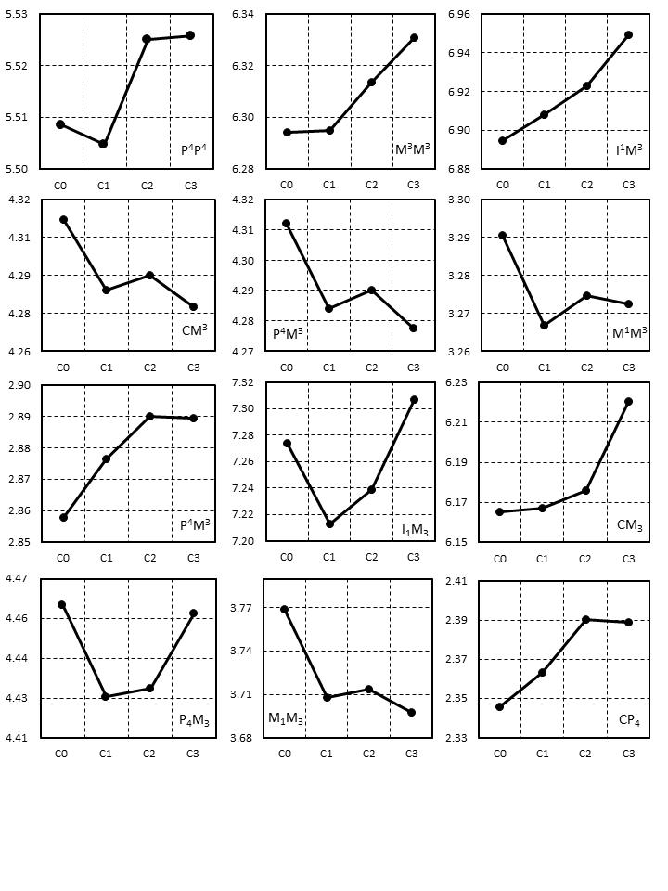

**Fig. S1.** Graphs of mean values of cranio-dental measurements and of mean CS values for respective cohorts. See methods for explanation of dimension abbreviations.

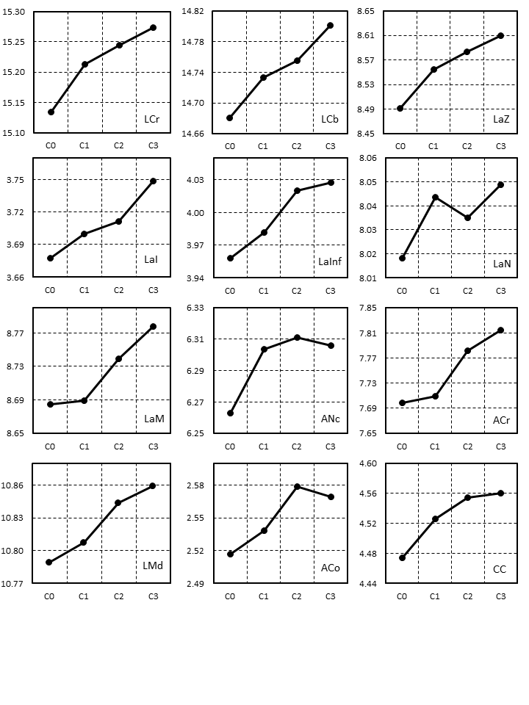

**Fig. S1.** (continued).

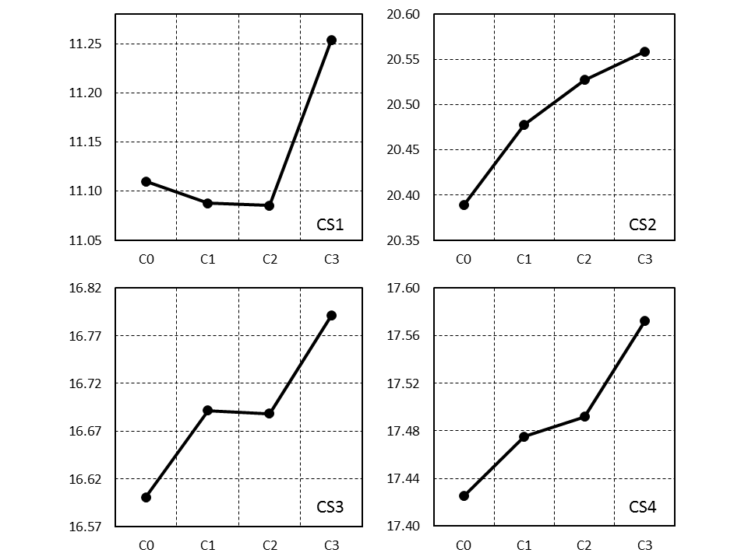

**Fig. S1.** (continued).

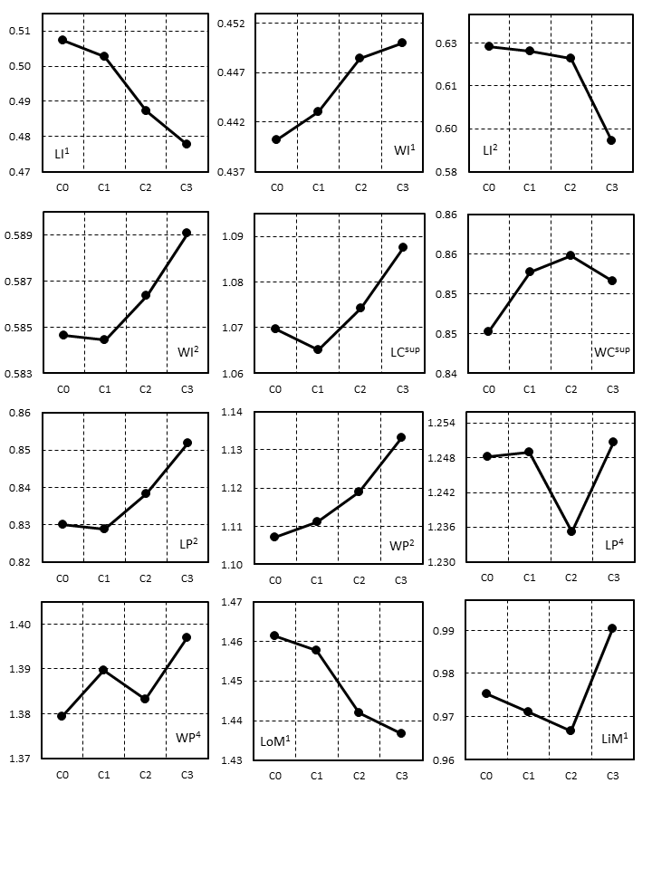

**Fig. S2.** Graphs of mean values of dental measurements for respective cohorts. See methods for explanation of dimension abbreviations.

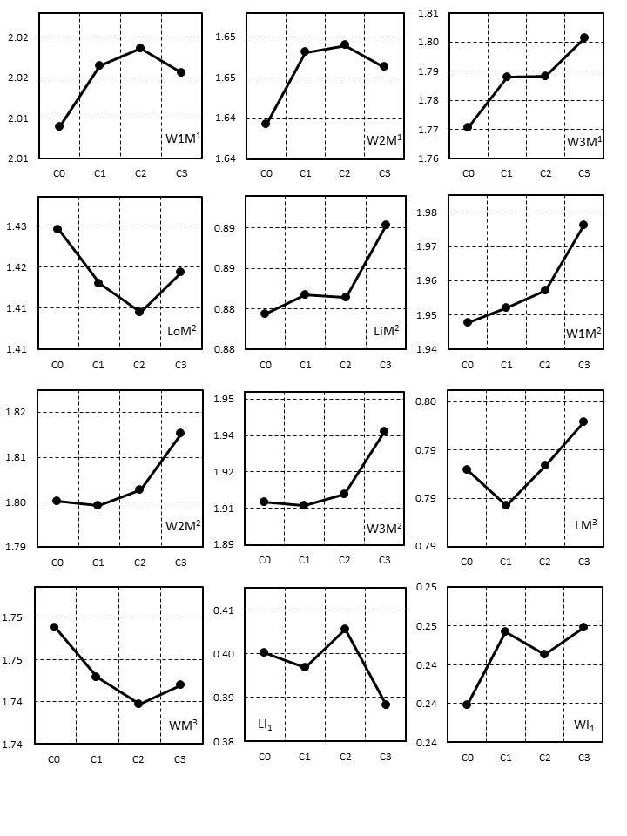

**Fig. S2.** (continued).

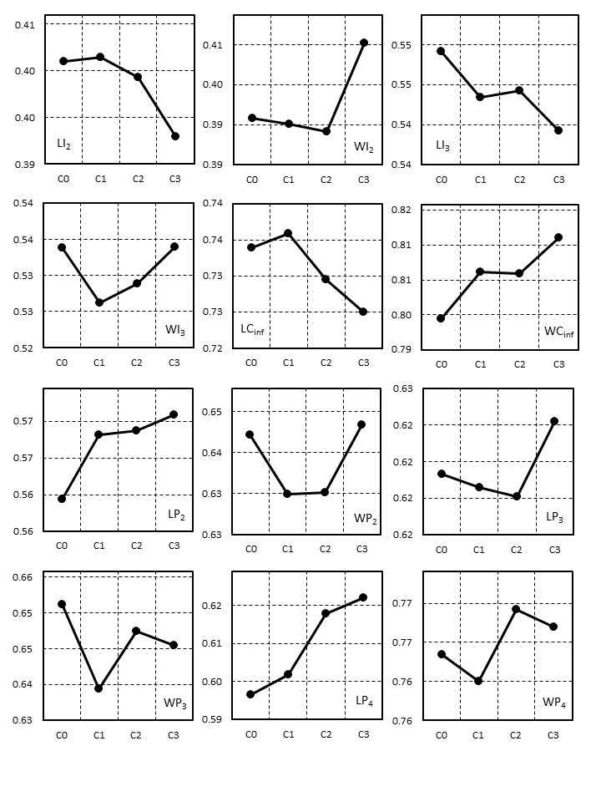

**Fig. S2.** (continued).

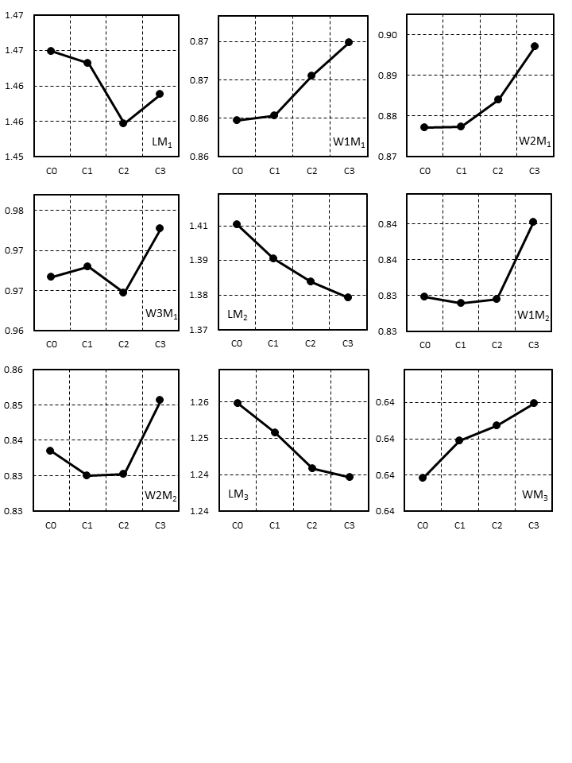 **Fig. S2.** (continued).

**Table S1.** Cranio-dental dimensions (in mm), CS and RW scores of the *Miniopterus* sexes in the respective populations. See methods for explanation of dimension abbreviations. *n* = number of specimens, M = mean, min = minimum value, max = maximum value, SD = standard deviation, * = P < 0.05, ** = P < 0.001, *** = P < 0.0001, F = F-values from ANOVA and T-test, SI = Storer’s index.



**Table S1.** (continued).



**Table S1.** (continued).



**Table S1.** (continued).



**Table S1.** (continued).



**Table S2.** Dental dimensions (in mm) of the *Miniopterus* sexes in the respective populations. See methods for explanation of dimension abbreviations. *n* = number of specimens, M = mean, min = minimum value, max = maximum value, SD = standard deviation, * = P < 0.05, ** = P < 0.001, *** = P < 0.0001, F = F-values from ANOVA and T-test, SI = Storer’s index.



**Table S2.** (continued).



**Table S2.** (continued).



**Table S2.** (continued).



**Table S2.** (continued).



**Table S3.** Non-metric traits of the *Miniopterus* sexes in the respective populations. See methods for explanation of dimension abbreviations. *n* = number of specimens, M = mean, min = minimum value, max = maximum value, SD = standard deviation, * = P < 0.05, ** = P < 0.001, *** = P < 0.0001, F = F-values from ANOVA and T-test, SI = Storer’s index.



**Table S3.** (continued).



**Table S3.** (continued).



**Table S3.** (continued).



**Table S3.** (continued).



**Table S4.** Dental dimensions (in mm) of the examined *M. schreibersii* age cohorts. See methods for explanation of dimension abbreviations. M = mean, min = minimum value, max = maximum value, and SD = standard deviation.



**Table S5.** Non-metric traits of the examined *M. schreibersii* age cohorts. See methods for explanation of dimension abbreviations. M = mean, min = minimum value, max = maximum value, and SD = standard deviation.

