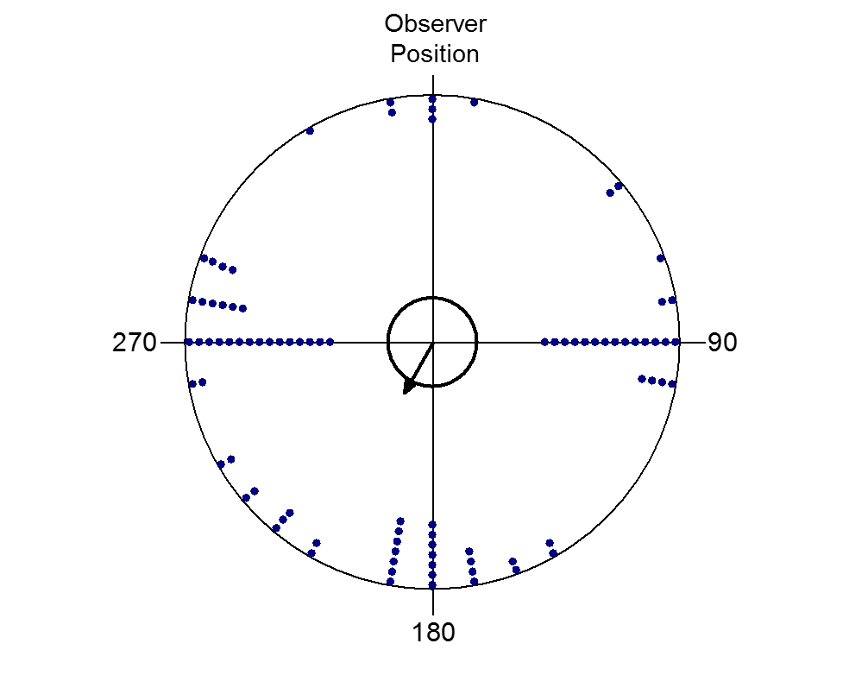

**Fig. S1.** Magnetic position of the observer during each mean measurement. Circular bearings on the periphery of the circle represent the magnetic position of the observer relative to the direction of each flock. Inner black circle shows the *p* = 0.05 significance cutoff and the black arrow shows the distribution’s mean direction and its length corresponds to the strength of clustering around the distribution mean. First-order Rayleigh test statistics are as follows: n = 89, µ = 210°, r = 0.23, *p* = 0.01.

**Table S1.** Number of individuals and number of mean bearings obtained from each sample location.



**Table S2.** Second-order analyses pooled relative to magnetic north and relative to the sun’s azimuth. Unlike Table 1 in the main text, these analyses include all independent measurements, regardless of flock size.

