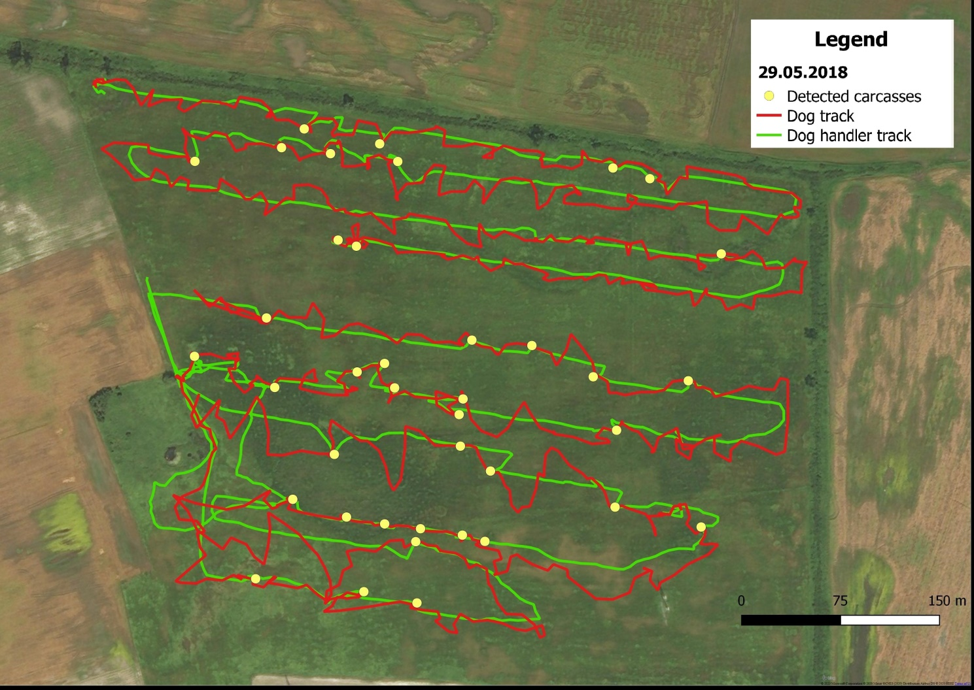Fig. S1. A sample map showing the dog and dog handler tracks and the locations of detected carcasses in a land parcel.

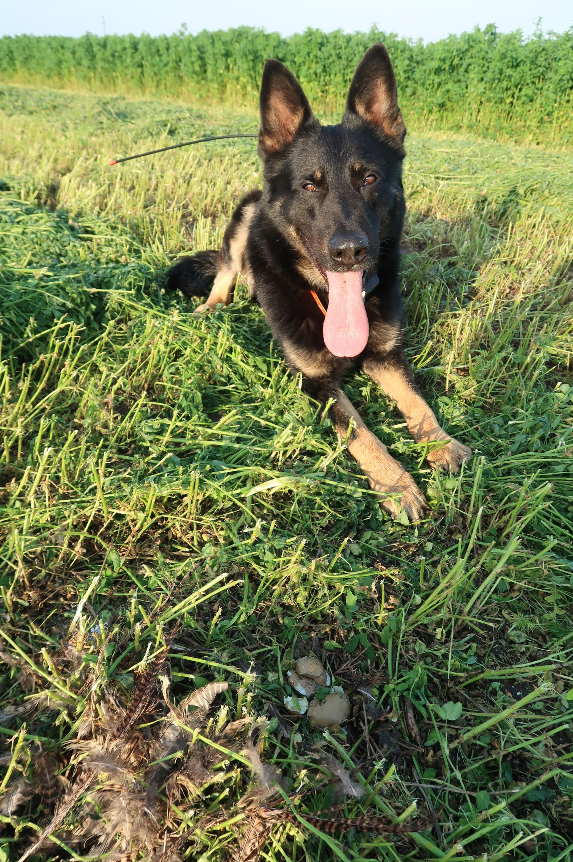
Fig. S2. Falco detecting a dead pheasant hen and destroyed nest under the mowed vegetation.

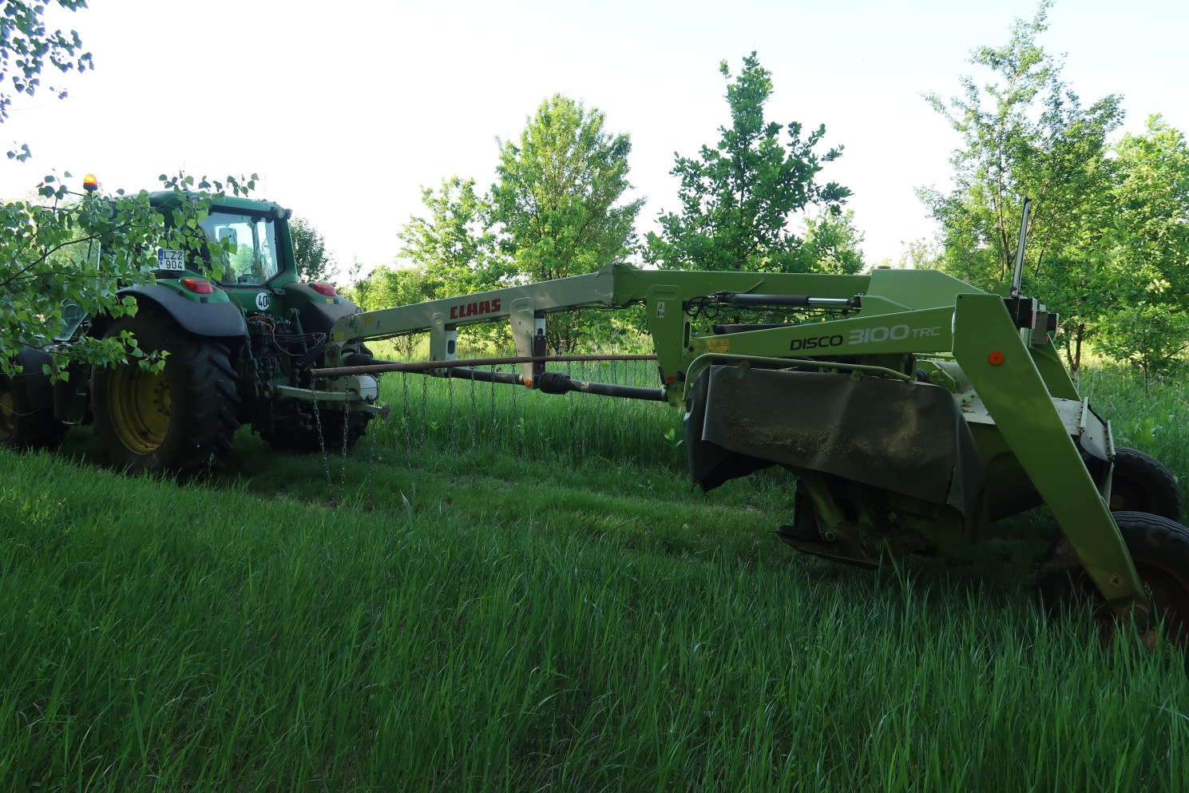
Fig. S3. Chain curtain in use (attached between the tractor and the blades).

Table S1. Distribution of different species in the total number of detected carcasses in two different habitat types, in Hungary (May-June, 2018). *In case of pheasant and quail one occasion in leguminous vegetation relates to the destruction of an entire clutch, for both.

Species | Cultivation |  | Total cases | Proportion %
 | Leguminous | Meadow
sand lizard Lacerta agilis | 13 | 64 | 77 | 51.67
grass snake Natrix natrix | 1 | 7 | 8 | 5.37
Eurasian skylark Alauda arvensis | 2 | 2 | 4 | 2.68
common pheasant* Phasianus colchicus | 2 | 1 | 3 | 2.01
common quail* Coturnix coturnix | 2 | 0 | 2 | 1.34
European brown hare Lepus europaeus | 4 | 4 | 8 | 5.37
roe deer Capreolus capreolus | 2 | 3 | 5 | 3.36
common vole Microtus arvalis | 8 | 6 | 14 | 9.40
mound-building mouse Mus spicilegus | 3 | 1 | 4 | 2.68
striped field mouse Apodemus agrarius | 1 | 1 | 2 | 1.34
unidentified rodent Rodentia | 10 | 1 | 11 | 7.38
unidentified remain | 7 | 4 | 11 | 7.38
Total | 55 | 94 | 149 | 100

Table S2. Observed parameters during searches with a carcass detection dog after mowing in various vegetated types, Hungary (May-June, 2018). Morning and afternoon searches were carried out within the time range from 9:21 to 13:31 and 16:25 to 20:10, respectively.

Date of search | Cultivation | Size of searched field (ha) | Time of searching | Number of detected items/100 ha  (carcass, remains or nest)
 |  |  |  | Total | Mammals | Birds | Reptiles | Unidentified
02.05.2018 | leguminous | 9.6 | afternoon | 52.08 | 10.42 | 31.25 | 10.42 | 0
03.05.2018 | leguminous | 13 | morning | 15.38 | 7.69 | 0 | 7.69 | 0
04.05.2018 | leguminous | 2.2 | morning | 0 | 0 | 0 | 0 | 0
28.05.2018 | meadow | 4.6 | morning | 260.87 | 130.43 | 0 | 130.43 | 0
28.05.2018 | meadow | 5.5 | morning | 181.82 | 36.36 | 0 | 145.45 | 0
28.05.2018 | meadow | 5.5 | morning | 254.55 | 18.18 | 18.18 | 181.82 | 36.36
29.05.2018 | meadow | 8 | morning | 137.50 | 37.50 | 0 | 87.50 | 12.50
29.05.2018 | meadow | 12 | afternoon | 233.33 | 33.33 | 16.67 | 175.00 | 8.33
30.05.2018 | meadow | 9 | morning | 211.11 | 0 | 0 | 211.11 | 0
17.06.2018 | leguminous | 20 | afternoon | 95.00 | 40.00 | 10.00 | 30.00 | 15.00
17.06.2018 | leguminous | 2.2 | afternoon | 681.82 | 545.45 | 45.45 | 45.45 | 45.45
19.06.2018 | leguminous | 2.6 | afternoon | 538.46 | 230.77 | 0 | 192.31 | 115.38
Total |  | 94.2 |  | 158.17 | 46.71 | 9.55 | 90.23 | 11.68

