Fig. S1. Median (±IQR) of initial detection distance to hedgehog in relation to method (infra-red thermal camera, detection dog, spotlight), habitat (amenity grassland, woodland) and ground cover (low: bare ground or mown grass; high: less than the height of the hedgehog or higher). Figures above columns are the number of hedgehogs detected.

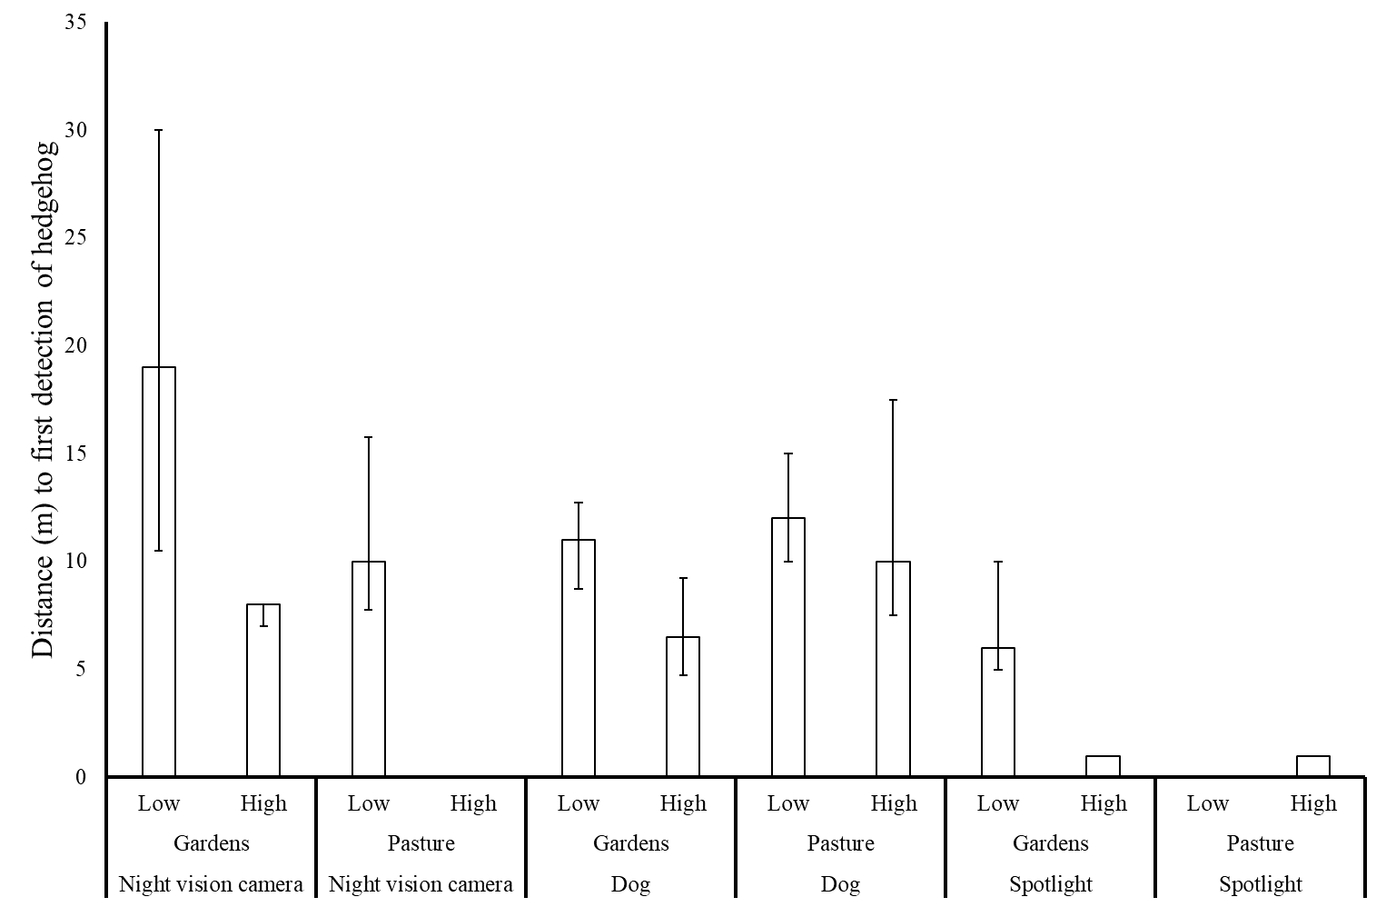
(1)
(2)
(5)
(3)
(5)
(8)
(4)
(0)
(0)
(4)
(5)
(10)

