Territorial behaviour of male roe deer: a telemetry study of spatial behaviour and activity levels

Nives PAGON, Stefano GRIGNOLIO, Francesca BRIVIO, Andrea MARCON and Marco APOLLONIO

¹ University of Sassari, Department of Veterinary Medicine, Via Vienna 2, I-07100, Sassari, Italy;
e-mail: sgrigno@uniss.it
² Slovenia Forest Service, Večna pot 2, Sl-1000 Ljubljana, Slovenia

Supplementary materials
Fig. S1. Activity levels (mean ± SE) of three male roe deer groups from the North-Eastern Apennines (grouped according to their spatial behaviour) in three bimonths during the territorial period, from March to August 2009.

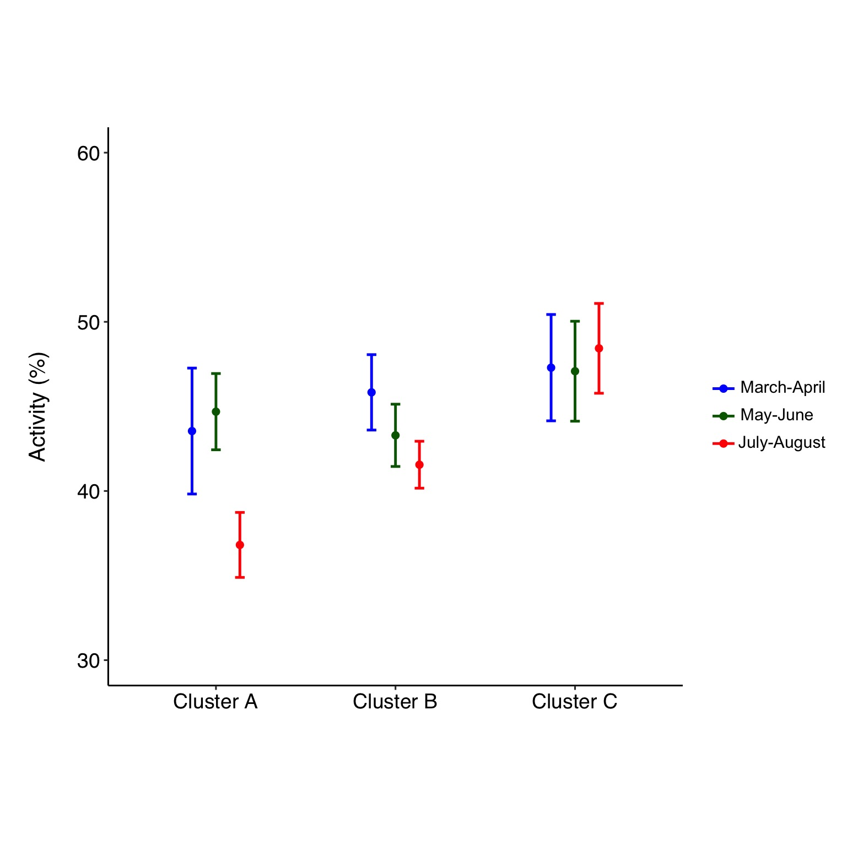

Table S1. Model selection based on linear mixed models explaining the variation in male roe deer activity levels from the North-Eastern Apennines, Central Italy, from March to August 2009. Empty space: term not included in a given model; BF: broadleaved forests; df: degrees of freedom; log Lik: log likelihood; AICc: corrected Akaike information criterion; Δ AICc: difference in the AICc value between a given model and the most parsimonious one; w: Akaike weight. Models are ordered by ascending AICc values, with the confidence set of six models at the top of the list in bold.

Intercept | Age class | Bimonth | Cluster | Day period | BF | Shrubs | df | log Lik | AICc | Δ AICc | w
✔ | ✔ |  | ✔ | ✔ | ✔ | ✔ | 12 | 223.27 | –421.8 | 0 | 0.166
✔ | ✔ | ✔ | ✔ | ✔ | ✔ | ✔ | 14 | 224.9 | –420.8 | 0.98 | 0.101
✔ |  | ✔ |  | ✔ |  |  | 8 | 218.22 | –420.1 | 1.71 | 0.07
✔ | ✔ | ✔ |  | ✔ |  |  | 10 | 220.27 | –420 | 1.79 | 0.068
✔ | ✔ | ✔ |  | ✔ | ✔ |  | 11 | 221.3 | –420 | 1.83 | 0.066
✔ | ✔ |  |  | ✔ | ✔ | ✔ | 10 | 220.18 | –419.9 | 1.97 | 0.062
✔ | ✔ | ✔ |  | ✔ | ✔ | ✔ | 12 | 222.18 | –419.6 | 2.18 | 0.056
✔ | ✔ |  |  | ✔ |  |  | 8 | 217.74 | –419.2 | 2.67 | 0.044
✔ |  |  |  | ✔ |  |  | 6 | 215.62 | –419.1 | 2.77 | 0.041
✔ | ✔ | ✔ | ✔ | ✔ | ✔ |  | 13 | 222.71 | –418.6 | 3.23 | 0.033
✔ |  |  |  | ✔ |  | ✔ | 7 | 216.25 | –418.2 | 3.59 | 0.028
✔ | ✔ |  |  | ✔ |  | ✔ | 9 | 218.28 | –418.2 | 3.67 | 0.026
✔ |  | ✔ |  | ✔ |  | ✔ | 9 | 218.25 | –418.1 | 3.73 | 0.026
✔ |  | ✔ |  | ✔ | ✔ |  | 9 | 218.24 | –418.1 | 3.76 | 0.025
✔ | ✔ | ✔ |  | ✔ |  | ✔ | 11 | 220.29 | –418 | 3.85 | 0.024
✔ |  | ✔ | ✔ | ✔ |  |  | 10 | 219.08 | –417.7 | 4.17 | 0.021
✔ | ✔ |  |  | ✔ | ✔ |  | 9 | 217.84 | –417.3 | 4.55 | 0.017
✔ |  |  |  | ✔ | ✔ |  | 7 | 215.75 | –417.3 | 4.57 | 0.017
✔ | ✔ | ✔ | ✔ | ✔ |  |  | 12 | 220.85 | –417 | 4.84 | 0.015
✔ |  |  | ✔ | ✔ |  |  | 8 | 216.5 | –416.7 | 5.16 | 0.013
✔ |  |  |  | ✔ | ✔ | ✔ | 8 | 216.4 | –416.5 | 5.35 | 0.011
✔ |  | ✔ |  | ✔ | ✔ | ✔ | 10 | 218.36 | –416.2 | 5.61 | 0.01
✔ | ✔ |  | ✔ | ✔ |  |  | 10 | 218.35 | –416.2 | 5.63 | 0.01
✔ |  |  | ✔ | ✔ |  | ✔ | 9 | 217.08 | –415.7 | 6.08 | 0.008
✔ |  | ✔ | ✔ | ✔ | ✔ |  | 11 | 219.14 | –415.7 | 6.14 | 0.008
✔ |  | ✔ | ✔ | ✔ |  | ✔ | 11 | 219.1 | –415.6 | 6.23 | 0.007
✔ | ✔ |  | ✔ | ✔ |  | ✔ | 11 | 218.91 | –415.2 | 6.62 | 0.006
✔ | ✔ | ✔ | ✔ | ✔ |  | ✔ | 13 | 220.87 | –414.9 | 6.91 | 0.005
✔ |  |  | ✔ | ✔ | ✔ |  | 9 | 216.56 | –414.7 | 7.11 | 0.005
✔ | ✔ |  | ✔ | ✔ | ✔ |  | 11 | 218.64 | –414.7 | 7.15 | 0.005
✔ |  |  | ✔ | ✔ | ✔ | ✔ | 10 | 217.36 | –414.2 | 7.61 | 0.004
✔ |  | ✔ | ✔ | ✔ | ✔ | ✔ | 12 | 219.3 | –413.9 | 7.93 | 0.003
✔ | ✔ |  | ✔ |  | ✔ | ✔ | 9 | 180.75 | –343.1 | 78.73 | 0
✔ | ✔ | ✔ | ✔ |  | ✔ | ✔ | 11 | 182.1 | –341.6 | 80.23 | 0
✔ | ✔ |  |  |  | ✔ | ✔ | 7 | 177.56 | –340.9 | 80.97 | 0
✔ | ✔ | ✔ |  |  | ✔ |  | 8 | 178.52 | –340.7 | 81.11 | 0
✔ |  | ✔ |  |  |  |  | 5 | 175.19 | –340.2 | 81.58 | 0
✔ | ✔ | ✔ |  |  |  |  | 7 | 177.24 | –340.2 | 81.6 | 0
✔ | ✔ |  |  |  |  |  | 5 | 175.16 | –340.2 | 81.63 | 0
✔ | ✔ | ✔ |  |  | ✔ | ✔ | 9 | 179.28 | –340.1 | 81.68 | 0
✔ |  |  |  |  |  |  | 3 | 173.05 | –340 | 81.79 | 0
✔ | ✔ | ✔ | ✔ |  | ✔ |  | 10 | 180.12 | –339.7 | 82.09 | 0
✔ |  |  |  |  |  | ✔ | 4 | 173.55 | –339 | 82.82 | 0
✔ | ✔ |  |  |  |  | ✔ | 6 | 175.58 | –339 | 82.85 | 0
✔ | ✔ |  |  |  | ✔ |  | 6 | 175.39 | –338.6 | 83.23 | 0
✔ |  | ✔ |  |  | ✔ |  | 6 | 175.22 | –338.3 | 83.58 | 0
✔ |  | ✔ |  |  |  | ✔ | 6 | 175.21 | –338.2 | 83.59 | 0
✔ | ✔ | ✔ |  |  |  | ✔ | 8 | 177.25 | –338.2 | 83.66 | 0
✔ |  |  |  |  | ✔ |  | 4 | 173.13 | –338.2 | 83.66 | 0
✔ |  | ✔ | ✔ |  |  |  | 7 | 176.05 | –337.8 | 83.98 | 0
✔ |  |  | ✔ |  |  |  | 5 | 173.92 | –337.7 | 84.12 | 0
✔ | ✔ |  | ✔ |  |  |  | 7 | 175.77 | –337.3 | 84.55 | 0
✔ |  |  |  |  | ✔ | ✔ | 5 | 173.7 | –337.3 | 84.57 | 0
✔ | ✔ | ✔ | ✔ |  |  |  | 9 | 177.82 | –337.2 | 84.6 | 0
✔ |  |  | ✔ |  |  | ✔ | 6 | 174.38 | –336.6 | 85.26 | 0
✔ |  | ✔ |  |  | ✔ | ✔ | 7 | 175.33 | –336.4 | 85.43 | 0
✔ | ✔ |  | ✔ |  | ✔ |  | 8 | 176.33 | –336.3 | 85.49 | 0
✔ | ✔ |  | ✔ |  |  | ✔ | 8 | 176.2 | –336.1 | 85.75 | 0
✔ |  | ✔ | ✔ |  | ✔ |  | 8 | 176.14 | –335.9 | 85.88 | 0
✔ |  | ✔ | ✔ |  |  | ✔ | 8 | 176.06 | –335.8 | 86.03 | 0
✔ |  |  | ✔ |  | ✔ |  | 6 | 173.95 | –335.7 | 86.12 | 0
✔ | ✔ | ✔ | ✔ |  |  | ✔ | 10 | 177.83 | –335.2 | 86.66 | 0
✔ |  |  | ✔ |  | ✔ | ✔ | 7 | 174.66 | –335.1 | 86.77 | 0
✔ |  | ✔ | ✔ |  | ✔ | ✔ | 9 | 176.28 | –334.1 | 87.68 | 0

